Assignment 2

CSE608

Advanced Software Engineering

Dr. Islam El-Maddah

**Due 2 10-Feb 2021**

**To be Handed as a word/pdf file for teams of two or individually**

**Part one**. Below is a state transition diagram for a microwave oven there are four output variables door closed or open, heat is on or off and there is error or not. There are also five input variables or events start, reset error, open and close door. Done.

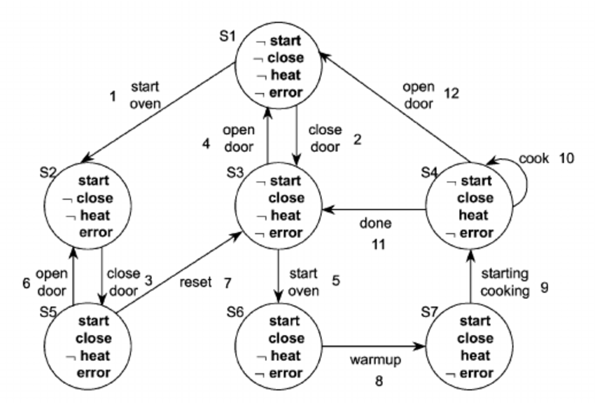

Close door

Door open

No heat

start

Door closed

No heat

open door

Door closed

Heat

STD

Open door

done

State Chart

Door closed

Heat off

Done | Open

open

start

close

Heat on

Door open

1. Describe each state with an adverb noun
2. Create an event list for the normal life cycle of microwave use what are the state sequence for this
3. Prepare a state coverage test to make sure the state transition diagram is been tested correctly
4. Prepare a minimum event coverage test to make sure the state transition diagram has been tested correctly

**Test case (event list + expected ouput)**

1. Create a state chart based on variables door and heat only remove the concept of error and reset but do not allow heat if the door is open

Part two (testing). Given the following C program to find if a given number is prime or not

A prime number only divides one and itself as shown in the following table

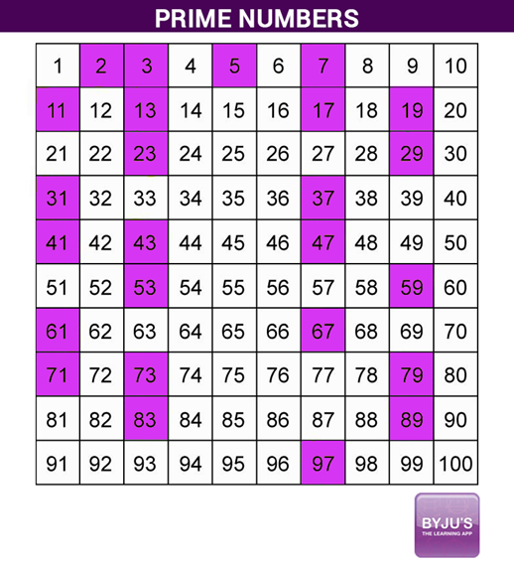

/* C Program to Find Prime Number using For Loop */

#include <stdio.h>

int main()

{

int i, Number, count = 0;

printf("\n Please Enter any number to Check for Prime \n");

scanf("%d", &Number);

for (i = 2; i <= Number/2; i++)

{

if(Number%i == 0)

{

count++;

break;

}

}

if(count == 0 && Number != 1 )

{

printf("\n %d is a Prime Number", Number);

}

else

{

printf("\n %d is Not a Prime Number", Number);

}

return 0;

}

I< number /2

I=2

If Number%i ==0

If count==1

I++

Count++

Not prime

prime

cc=e-n+2

cc= number of enclosed areas +1

cc = 1 +ifs+fors

end

1. create a blackbox Test cases assume number must be positive and integer

TC1 ( 5, output=’Prime’)

TC2 (8, output=’not Prime’)

1. What is the result of entering number = 15 and what is the expected output

Not prime = expected not prime

1. create a control flow chart of the above program and determine its complexity
2. create a test suite fulfilling statement coverage

TC1(input =4, output=not prime), TC2(input = 7 , output= prime)

1. create a test suite fulfilling branch coverage

Tc1 ( 4) TC2( 7)

1. create a test suite fulfilling ADUP

Di

Dn

Input number

I=2

Count=0

I< number /2

Dc

Ui Un

If Number%i ==0

Ui Un

If count==1

Ui Di

Uc

I++

Count++

Uc Dc

Un

Not prime

prime

cc=e-n+2

Un

cc= number of enclosed areas +1

cc = 1 +ifs+fors

end

ADUP

1->3 1->4 1->8 1->9

2->3 2->4 2->5

5->3 5->4 5->5

0->6 0->7 6->7